

**Administration** 0117 902 0345

theatre@tobaccofactorytheatres.com

**Box Office** 0117 902 0344

tickets@tobaccofactorytheatres.com­

tobaccofactorytheatres.com

Raleigh Road, Southville, Bristol BS3 1TF

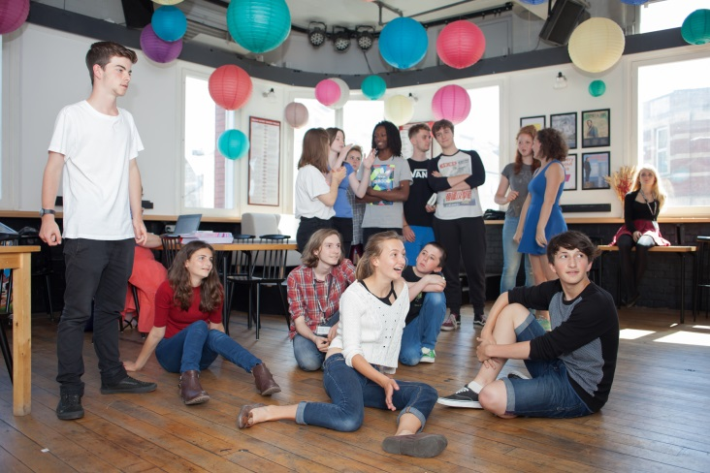

**Tobacco Factory Theatres produces and presents a jam-packed programme of excellent theatre in unique, intimate spaces, in Bristol and beyond, with exciting opportunities for artists and young people.**

We present a jam-packed programme of diverse and exciting shows, workshops and events, from classic and contemporary theatre, to theatre for families, comedy, dance, music, opera and puppetry. We also programme an extensive programme of engagement, learning and participation opportunities for audiences, artists and young people.

**WORK EXPERIENCE**

As part of our CYP programme, we are thrilled to be opening our doors and offering work experience placements to local young people. We are inviting three young people (Year 10/11) to join us for one week where they will have exclusive access to the inner workings of our theatre, as well as the opportunity to develop employability skills which can be included on their CVs.

Dates for 2018: **Mon 02 July - Fri 06 July 2018**

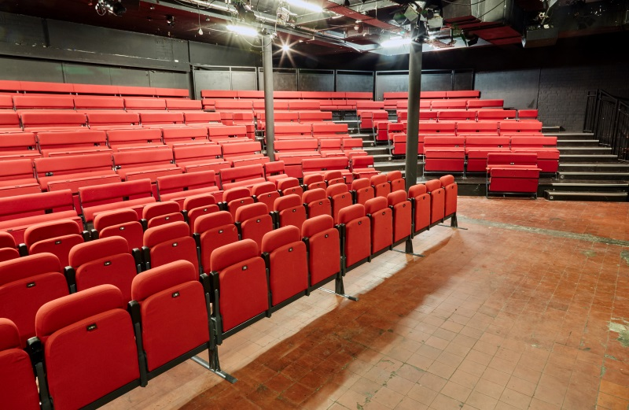

**THE PLACEMENT:**

As part of your placement, you will…

* Observe rehearsals in the theatre
* Shadow various staff in different roles including producing, marketing, box office and development
* Complete an independent project (all three students together) which will be presented to the theatre staff

**TO APPLY:**

As one of the few theatre venues offering work experience in the region, there is fierce competition for these places. Due to this (and to offer a professional experience to all those interested) there is an application process:

* Please complete and submit an application form by **5pm Mon 15 January 2018** and email it to [theatre@tobaccofactorytheatres.com](mailto:theatre@tobaccofactorytheatres.com) with ‘WORK EXPERIENCE’ in the subject line.
* Shortlisted candidates will be contacted by **Mon 22 January 2018** and invited to interview in mid-February.
* Successful candidates will be notified shortly after this.

For more information, please email Bryony Roberts at [bryony@tobaccofactorytheatres.com](mailto:bryony@tobaccofactorytheatres.com) or Ailie deBonnaire at [ailie@tobaccofactorytheatres.com](mailto:ailie@tobaccofactorytheatres.com) or call 0117 902 0345